Installation of an Ubuntu Web Server (Apache)

Objective:
To install and configure an Apache web server on an Ubuntu system and verify that it is accessible via a web browser.

Step 1: Update the System and Install Apache
The system package index was updated, and the Apache web server was installed using the Advanced Package Tool (APT).

Bash Script:
sudo apt update && sudo apt install apache2 -y

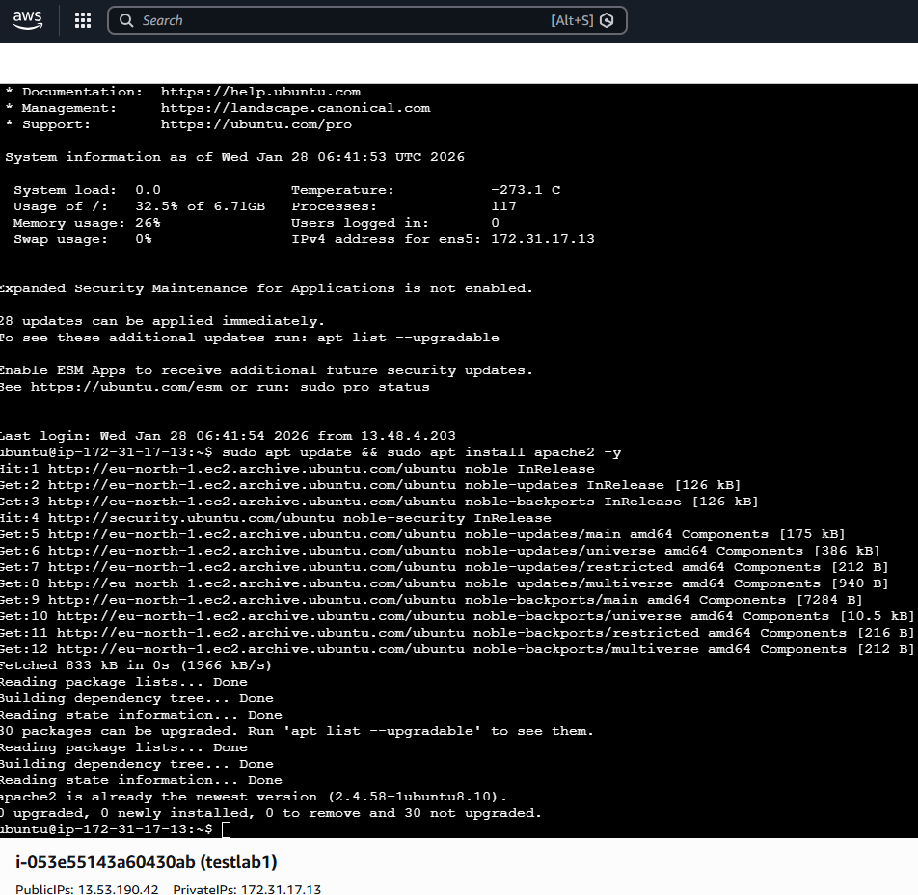

This command ensures the latest package information is retrieved and installs Apache without requiring manual confirmation.

Step 2: Verify Apache Service Status
After installation, the Apache service was checked to confirm it was running successfully.

Bash Script:
sudo systemctl status apache2

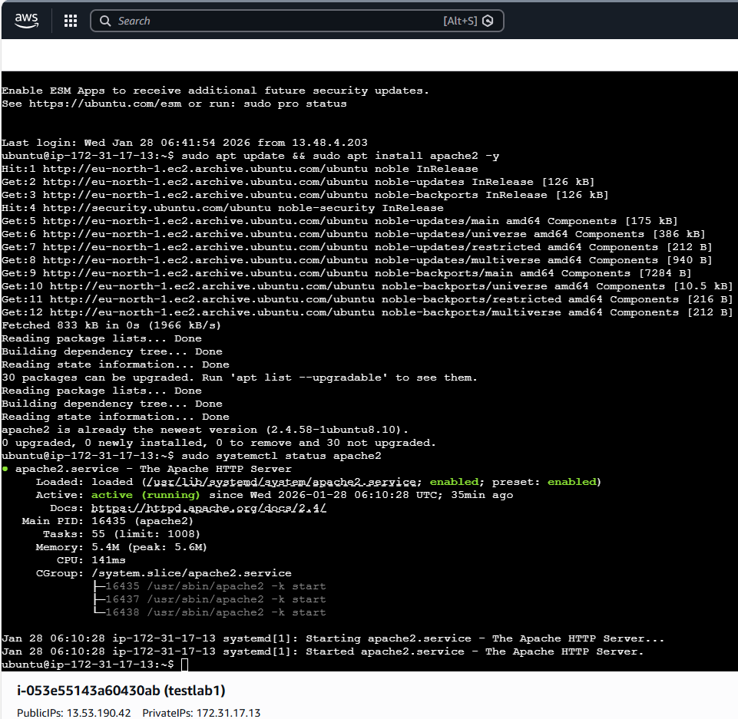

Step 3: Configure Firewall Rules (If enabled)
The Uncomplicated Firewall (UFW) was checked and configured to allow HTTP traffic on port 80.

Bash Script:
sudo ufw allow 'Apache'
sudo ufw reload

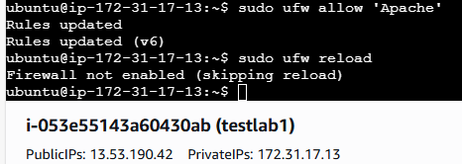

This ensures that external clients can access the web server.

Step 4: Test Web Server Accessibility
The server’s IP address was identified and used to test Apache in a web browser.

Bash Script:
hostname -I

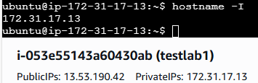

Navigating to http://172.31.17.13 displayed the Apache2 Ubuntu Default Page, confirming successful deployment.

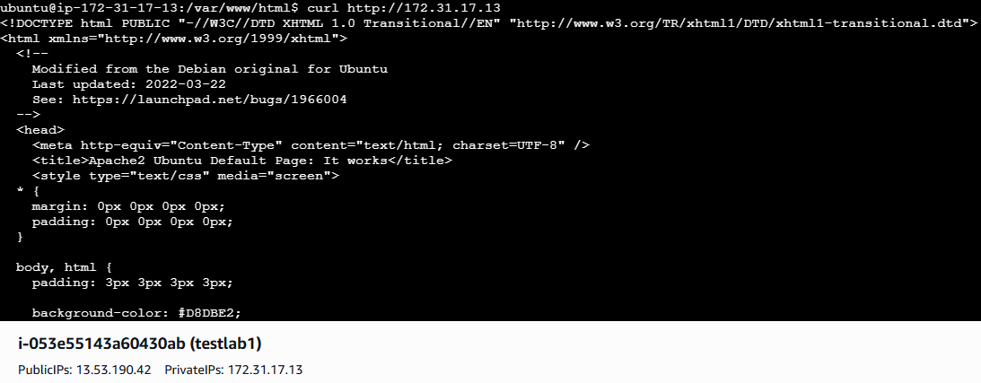
Step 5: Identify the Web Root Directory
Apache’s default document root was verified.

Bash Script:
cd /var/www/html
ls

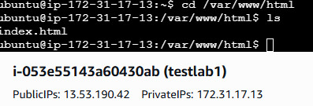

The default index.html file confirmed the web server’s content location

Quick SOC-style checks:
- Apache running? sudo systemctl status apache2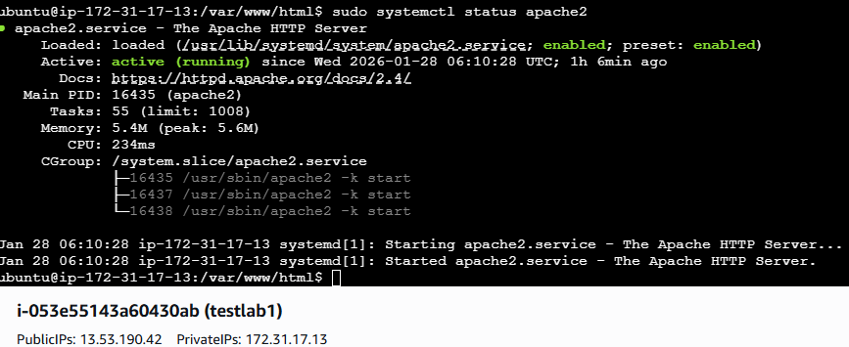

- Listening on port 80? ss -tulnp | grep apache2
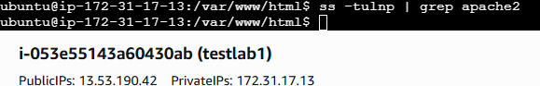

- Firewall blocking access if enabled? sudo ufw status
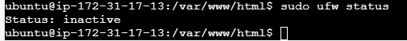

- Testing locally on the server itself curl http://localhost
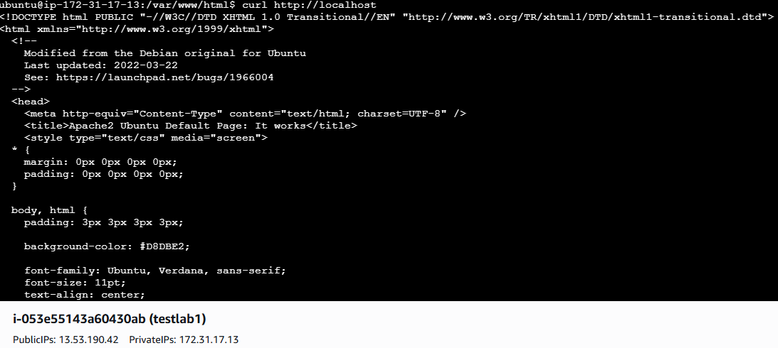
w3.org/TR/xhtml1/DTD/xhtml1-transitional.dtd

